##### A SUMMER TRAINING PROJECT REPORT

**INDIAN KISAN**

**Submitted by**

###### Team members- Sonal (06713502711)

###### Manali Verma (06813502711)

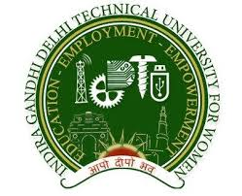

Under the guidance of

Dr. SRN Reddy

Associate Professor, IGDTUW

***In partial fulfillment for the award of the certificate***

***In***

**“Mobile architecture and Programming by using Windows Phone 7/8, J2ME (Series 40)”**

**Organizing by CSE Dept, Indira Gandhi Delhi Technical University For Women, Delhi in collaboration with Nokia University Relations**

(From 21-06-2013 to 31-07-2013)